

Applications of dijkstra’s algorithm



Applications Of Dijkstra’s Algorithm

**Telecommunication Networks**

In telecommunication networks, data must be transmitted efficiently between devices across a network of routers and servers. Dijkstra's algorithm helps by identifying the shortest (or least costly) path through these networks, optimizing signal and data transfer. Here’s how it applies:

* **Optimizing Data Flow**: Dijkstra's algorithm calculates the shortest route for data packets to travel, minimizing delays and reducing the chance of congestion by avoiding crowded or slow paths.
* **Reducing Transmission Costs**: Since every link between nodes (routers, switches) might have an associated "cost" (based on latency, bandwidth, or actual cost), the algorithm minimizes these by finding the lowest-cost paths.
* **Reliable Communication**: Telecommunications use protocols like OSPF (Open Shortest Path First), which relies on Dijkstra’s algorithm to automatically adjust routes if network conditions change, like if a link goes down.

Game Development

In game development, Dijkstra's algorithm is widely used for pathfinding, especially in games that involve navigating complex terrains or environments. Here’s how it’s applied:

* **NPC Pathfinding**: Non-player characters (NPCs) need to navigate from one point to another, avoiding obstacles and reaching goals efficiently. Dijkstra’s algorithm allows NPCs to calculate the shortest path to their destination dynamically, making them seem more intelligent and responsive.
* **Dynamic Environments**: Many games have changing environments (like doors opening/closing or new obstacles). Dijkstra's algorithm can adapt, recalculating paths to respond to new obstacles or changes.
* **Realistic Movement**: For NPCs or units in strategy games, the algorithm ensures that movement feels realistic, as characters take the shortest and most sensible paths rather than wandering aimlessly.

Some examples of games are :

**Maze and Puzzle Games**

* Games involving mazes, like certain levels in *Pac-Man* or *Bomber man*, require characters to navigate efficiently through grid-based environments. Dijkstra's algorithm can calculate the shortest paths through these mazes, helping AI opponents or guiding the player to the exit quickly.

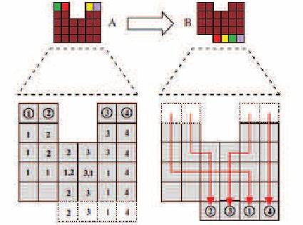

**Role-Playing Games (RPGs)**

* In RPG like *The Witcher* or *Skyrim*, non-playable characters (NPCs) move around the game world, interacting with objects and other characters. Dijkstra's algorithm can help these NPCs find paths to specific points, like a shop or a quest location, avoiding obstacles and taking the quickest route.

* This is the map of Witcher 3, if you want to go from one place to another it will use Dijkstra’s Algorithm to provide you the shortest route to that place.